

**La-Z-Boy launches new HQ in Monroe**

[**Lauren Abdel-Razzaq, The Detroit News**](http://www.detroitnews.com/staff/27327/lauren-abdel-razzaq)*9:49 p.m. EDT June 5, 2015*

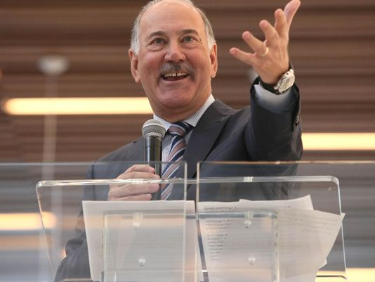

La-Z-Boy Chairman Kurt Darrow *(Photo: MADALYN RUGGIERO/Special to the News)*

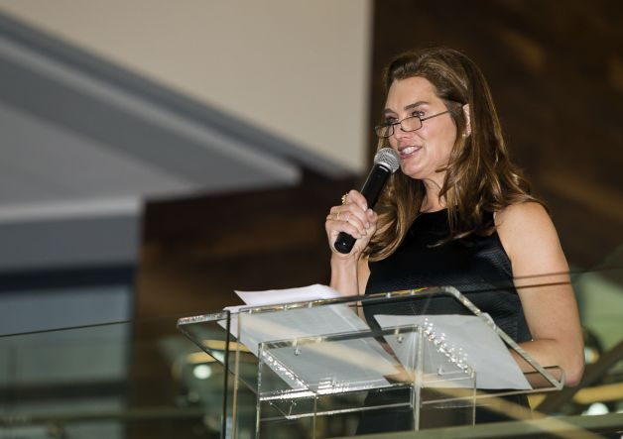

Brooke Shields speaks at the grand opening of the new La-Z-Boy world headquarters in Monroe, Mi., Friday, June 5, 2015. (Ed Keller/The Monroe Evening News via AP) (Ed Keller, AP / The Evening News)

*Monroe* — La-Z-Boy was founded in 1927, when Michigan led the world in manufacturing, whether that was in furniture, cereal, chemicals or cars. On Friday, as the company celebrated the opening of its new world headquarters here 88 years later, Gov. Rick Snyder said making world-class items in Michigan remains key.

“When you look around you, you see the best of Michigan,” Snyder told a gathering of about 100 employees, city officials and other dignitaries. “Made in Michigan does mean something really special again.”

The furniture maker built its $60 million global headquarters in its hometown of Monroe after being courted by several other cities in Michigan and Ohio. Monroe, Monroe County and the state put up $3.7 million in incentives to convince the company to stay in the city.

The deal for the land was finalized in January 2013, with the company acquiring 120 acres of pristine land that was maintained for decades by the Roman Catholic nuns of the Servants of the Immaculate Heart of Mary.

“It all started with this amazing piece of property and the Sisters’ faith that we would be good stewards of their land,”said Kurt Darrow, chairman, president and CEO of the company. “We appreciate their faith.”

The 200,000-square-foot, three-story facility took about 18 months to construct and is situated on 40 acres. The remaining 80 acres around the headquarters will remain an untouched nature preserve that features an existing oak savanna.

The design work was completed by The Collaborative and includes open work spaces, a full service kitchen and plenty of comfy furniture throughout the building.

It’s a stark contrast to the company's previous home, a beige boxy building off Telegraph Road whose neighbors were a White Castle and a Chinese restaurant. That building is up for sale by the Farbman Group.

Friday evening’s welcome party took place in the three-story glassed-in lobby. Guests walked in through the front entrance past an illuminated reflecting pool and waterfall and a back-lit ornamental glass wall.

They enjoyed a strolling dinner before remarks by Darrow, Snyder and spokeswoman and actress Brooke Shields. A ribbon cutting was held afterward.

Once known mainly for big, comfy “man” chairs, La-Z-Boy has been on an upward trajectory since the bottom of the recession. The new approach is reflected by Shields, who is the face of the company’s “Live Life Comfortably” campaign, as the company offers an increasingly upscale product line that caters to active families and homes with open floor plans.

“Thinking back to my first La-Z-Boy project, it’s amazing to see how the company keeps raising the bar,” Shields said. “It’s exciting to see where the company has been and where it is going to go.”

The company was founded in Monroe by cousins Edward M. Knabusch and Edwin J. Shoemaker. It went public in the 1970s.

“They were two cousins that had a dream to start their own business, and they worked their entire lives to make people comfortable, to bring good jobs to their employees and to embrace the communities they lived in,” Darrow said.

The stock price, which stood at 60 cents in early 2009 closed Friday four cents short of $27 a share. Its third-quarter earnings reported in February showed sales climbed 3.3 percent to $357.9 million from the same period a year ago.

The company is scheduled to announce its fourth-quarter and full-year results June 17.

The company has vowed to keep its new site, which the nuns kept as a nature preserve, as undisturbed as possible. La-Z-Boy said its headquarters meets “green building” standards such as LEED certification, and the property will have walking trails for employees.

The site, about a mile from the previous location, is located partly in Monroe and partly in Frenchtown Township. It officially opened in March and houses about 500 employees.

lrazzaq@detroitnews.com

(313) 222-2127

@laurenarazzaq